**Outline**

To research the history of computing technology and the development of individual hardware components. To prepare slides on a specific topic and present on the assigned to the class.

**Objectives**

* Describe the functions and features of the internal components of a computer (e.g., CPU, RAM, ROM, cache, hard drive, motherboard, power supply, video card, sound card);
* Use correct terminology to describe computer features and specifications (e.g., processor type, bus speed, storage capacity, amount of memory);

**Materials**

* None.

**Level 0: Personal Computer Internals**

1. Create a labeled diagram of the inside of a typical personal computer.
   1. You can do it electronically or on paper.
   2. The diagram cannot be a single clip art from the web but may use individual images from the web.
   3. The labels and arrows to the various components must be drawn by you.

Some computer components are :

The main components are:

Processor:

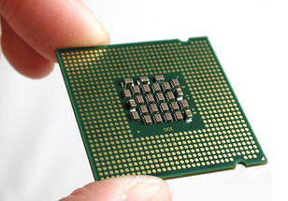

Main memory:

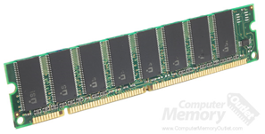

Secondary memory:

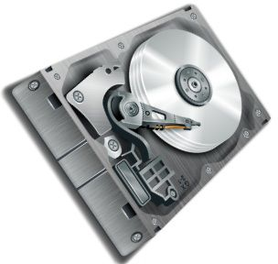

Input devices:

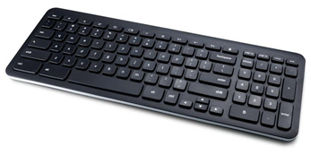

Output devices:

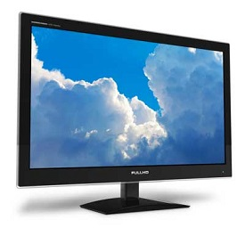

Motherboard:

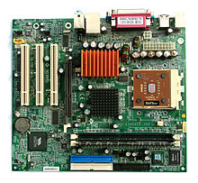

Graphics processing unit:

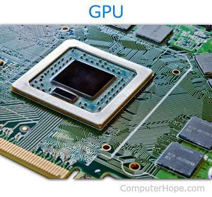

Power supply:

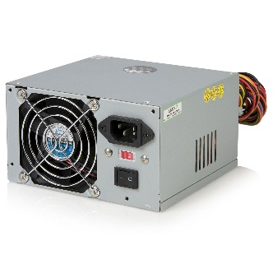

Case

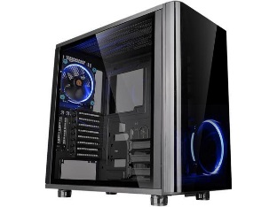

1. Labeling the Motherboard.
   1. Show the location of the CPU and CPU Fan.

CPU 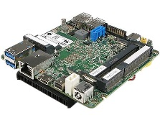 CPU Fan 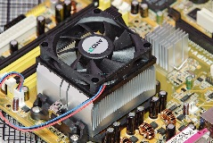

* 1. Show the location of the Memory Slots and RAM Memory

Memory slots 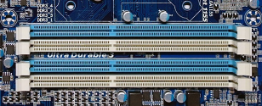 RAM Memory 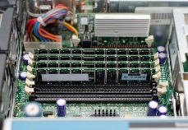

* 1. Show the location of the on-board video, sound, Ethernet/Wireless and USB devices

ON-board video 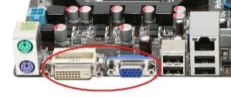 Sound 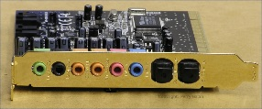 Ethernet 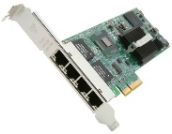

USB Devices 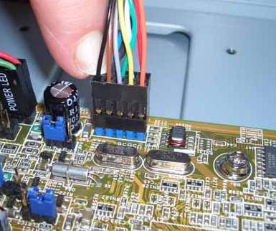

* 1. Show the location of the expansion slots and Video and Sound boards.

1. Labeling the Chassis Components.
   1. Show the location of Power Supply.

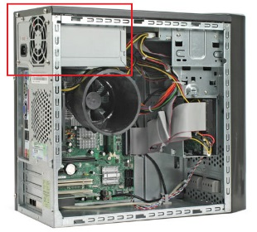

* 1. Show the location of the External Hard Drives and connections to the Motherboard

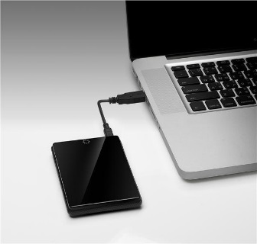

* 1. Show the location of the Removable Media Drives and connections to the Motherboard

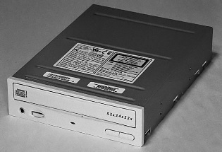

* 1. Show and label the external connector plate (i.e. where the monitor, keyboard, etc. are connected.)

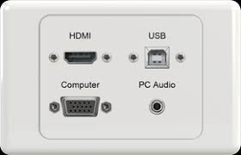

**Level 1: History of Computers**

1. Research the history of “Mainframe Computers”. Make notes on the following:
   1. The first computers (e,g, UNIVAC) and how they were made.
   2. Computers in the 1960s and 1970s (e.g. IBM)

- Group of manufacturers was first known as "IBM and the Seven Dwarfs"

- Burroughs,UNIVAC, NCR, Control Data, Honeywell, General Electric and RCA

* 1. Modern mainframe computers used by banks, government, and other large companies

1. Research the history of “Super Computers”. Make notes on the following:
   1. The first super computers (e,g, CRAY) and how they were made.
   2. Massively Parallel and Network Computers (e.g. Big Blue)
   3. Modern quantum computers and how they work
2. Research the history of “Personal Computers”. Make notes on the following:
   1. When was the first IBM PC introduced and what features did it have?
   2. What were some PCs before the IBM PC?
   3. When was the first Apple introduced and how was it different from the PC?
   4. How have modern PCs change since the earliest PCs?

**Level 2: History of Computer Components**

1. Research the history of the “CPU Chip”. Make notes on the following:
   1. When was the first CPU chip released (e,g, 8086) and who made it and what did it contain.
   2. What is an “Integrated Circuit” and how were computers made before ICs?
   3. How have CPU chips evolved since the 8086?
2. Research the history of “Computer Memory”. Make notes on the following:
   1. How is RAM memory used in PCs different from “Core Memory” used on early computers.
   2. What is “Moors Law” and how has RAM memory followed this law?
   3. How is RAM memory different from external memory (e.g. hard disks)?
   4. How has RAM memory evolved over time?
3. Research the history of “Video Cards”. Make notes on the following:
   1. What is VGA, when was it introduced and what features did it have?
   2. What came before VGA graphics?
   3. When were 3D graphics cards introduced and what were the first 3D cards like?
   4. How have graphics cards evolved over time?

**Level 3: History of Operating Systems**

1. What is a “Operating System”?
   1. How is it different from a software program

- Your computer's operating system (OS) manages all of the software and hardware on the computer. Most of the time, there are several different computer programs running at the same time, and they all need to access your computer's central processing unit (CPU), memory, and storage.

- A software program is commonly defined as a set of instructions, or a set of modules or procedures, that allow for a certain type of computer operation. The term is also often used interchangeably with terms like “software application” and “software product.”

* 1. What is a “Driver”?

- a group of files that enable one or more hardware devices to communicate with the computer's operating system. Without drivers, the computer would not be able to send and receive data correctly to hardware devices

* 1. What is a “Service”?

-A network service is an application running at the network application layer and above, that provides data storage, manipulation, presentation, communication or other capability which is often implemented using a client-server or peer-to-peer architecture based on application layer network

1. Research the history of the “Windows” operating system. Make notes on the following:
   1. What is DOS and how is it related to Windows?

-DOS or Disk Operating Systems are operating systems that were most commonly found the IBM PCs and were popular between 1981 and 1995.

-Windows is a range of graphical interface operating systems that are developed and sold by Microsoft.

* 1. What was the first version of Windows, when was it released and what did it contain?

- Windows 1.0 was released on November 20, 1985, as the first version of the Microsoft Windows line. It runs as a graphical, 16-bit multi-tasking shell on top of an existing MS-DOS installation. It provides an environment which can run graphical programs designed for Windows, as well as existing MS-DOS software.

* 1. Compare the history of the Apple OS with Windows?
  2. How has Windows evolved over time?

1. Research the history of “UNIX”. Make notes on the following:
   1. What is UNIX and what is the history of UNIX.
   2. What is LINUX and how is it related to UNIX?
   3. How is UNIX related to the Apple OS?

**Level 4: Presentation**

1. Create a full PowerPoint (or equivalent) presentation on the topic assigned by your teacher.
   1. The presentation should be 5 to 10 minutes in length

Presentation Topics

|  |  |
| --- | --- |
| History of the 8086 Microprocessor | History of RAM Memory |
| History of Hard Disk Drives | History of Removable Media Drives |
| History of CD / DVD Read Write Drives | History of VGA graphics |
| History of HDMI graphics | History of Portable / Laptop computers |
| History of Computer Display Screens | History of Desktop computers |
| History of Pointer (mouse) interfaces | History of Mainframe computers |
| History of Computer Backup Technologies | History of USB interfaces |
| History of Sound Cards | History of Dial-Up / Ethernet interfaces |
| History of Computer Cooling Technologies | History of Input Devices (Keyboards / Punch Cards) |
| History of Computer Networks | History of Office Software |
| History of Anti-Virus Software | History of Internet Browsers |

**Presentation Sign-Up**

|  |  |  |
| --- | --- | --- |
| **Student** | **Topic** | **Presentation Date** |
|  |  |  |
|  |  |  |
|  |  |  |
|  |  |  |
|  |  |  |
|  |  |  |
|  |  |  |
|  |  |  |
|  |  |  |
|  |  |  |
|  |  |  |
|  |  |  |
|  |  |  |
|  |  |  |
|  |  |  |
|  |  |  |
|  |  |  |
|  |  |  |
|  |  |  |
|  |  |  |
|  |  |  |
|  |  |  |
|  |  |  |
|  |  |  |